**IMDB Movie Analysis Report**

1 Movie Genre Analysis:

**Findings:**

* Most Common Genres: Drama, Comedy, Romance and Crime Thriller.

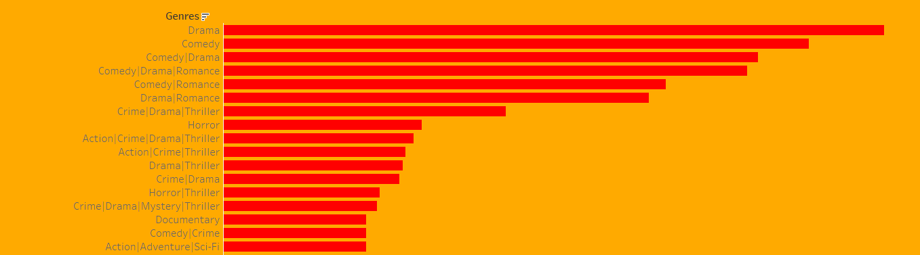

**2 Movie Duration Analysis:**

Findings:

Movie Duration: 80-150 minutes is most common.

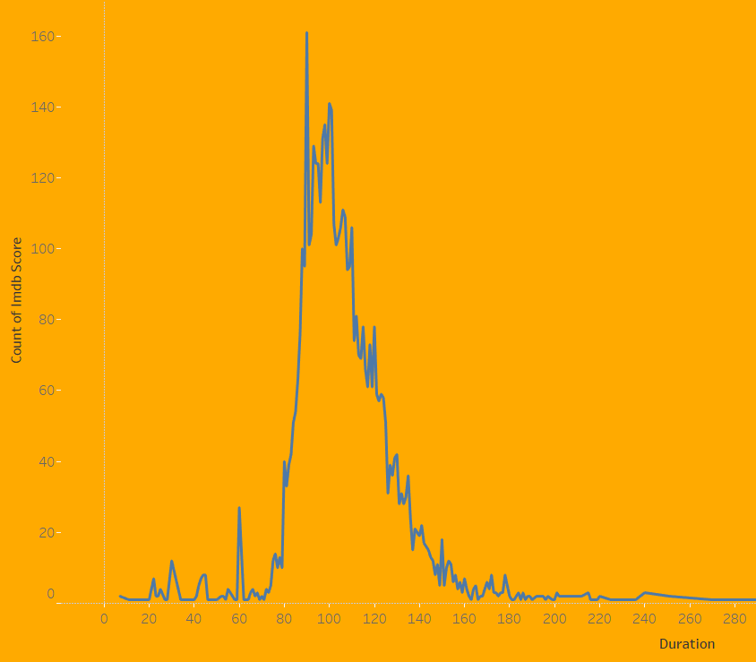

Relationship: Generally, movies with a duration between 80-150 minutes tend to have higher IMDB scores.

**3 Language Analysis:**

Findings:

Most Common Languages: English, French, Spanish.

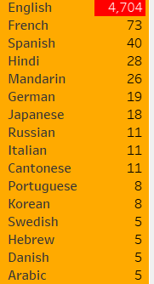

Relationship: Most common Language tent to have higher impact on IMDB score

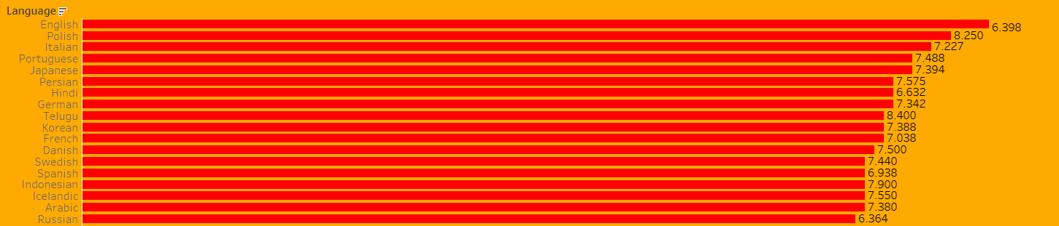

**4 Director Analysis:**

**Findings:** Highest ratedIMDB score for Director

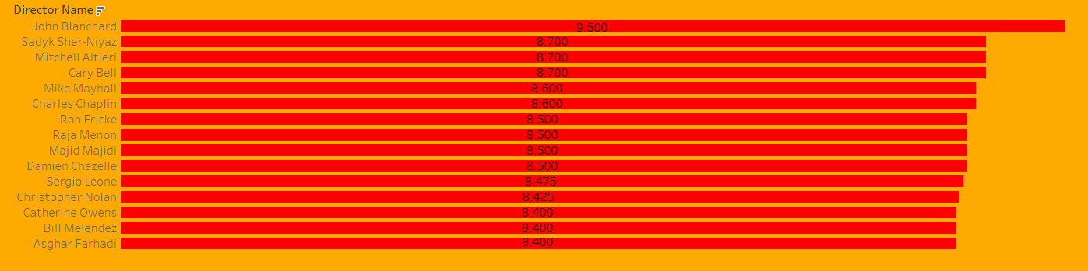

Relationship: Most Like director and most successful director they are more or less same

**5 Budget Analysis:**

**Findings:**

* **Correlation between Budget and Gross Earnings:** 0.102 correlation indicates that as the budget increases, the gross earnings tend to increase very slightly over all
* **Movies with the Highest Profit Margin :** Avengers, Avatar , The Jungle book

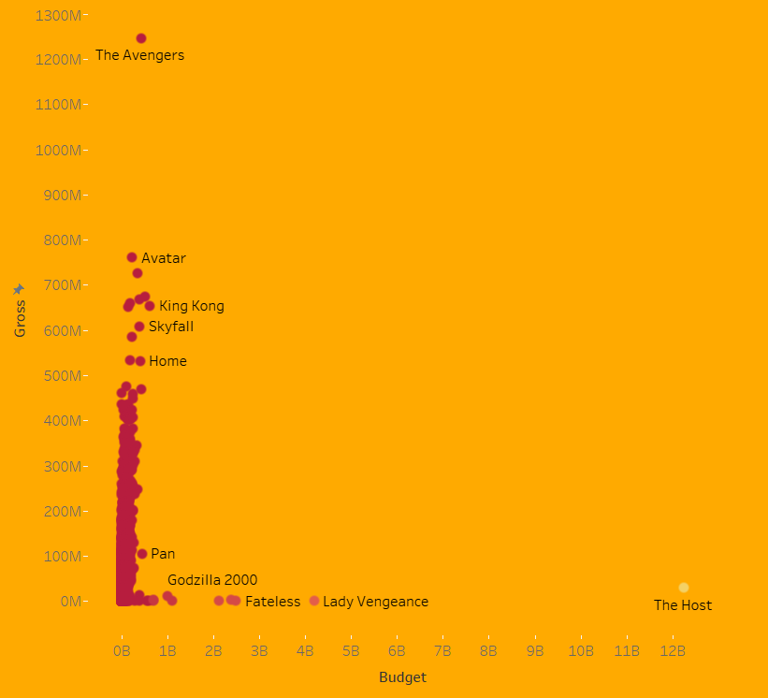

**Conclusion & Recommendations:**

1. Genre Insights: Dramas tend to have higher average IMDB scores compared to Action and Comedy genres.
2. Duration Insights: Movies with a duration between 80-150 minutes tend to be more favoured by audiences, reflecting in higher IMDB scores.
3. Language Insights: English-language movies, on average, have a slightly higher IMDB score compared to French and Spanish movies.
4. Director Insights: Directors like Steven Spielberg ,joss Wheldon, James Cameron have a more consistent track record of producing highly-rated movies, making them valuable assets for future projects.
5. Budget Insights: While theirs is very less correlation between budget and gross earnings, it's essential to focus on cost-effective strategies. Movies with the Highest Profit Margin: Avengers, Avatar, The Jungle book

Dashboard Details:

Link: https://public.tableau.com/app/profile/d.rajasekar/viz/IMDBAnalysis_17032501438960/IMDBDashboard?publish=yes

